McPhail Letter about Black Players

Dexter Cumberbatch, Twitter, Dec 18, 2020

My Guess: Informing Mayor LaGuardia’s committee, and MLB issued a statement on this in 1946, so must be about the same time.

1

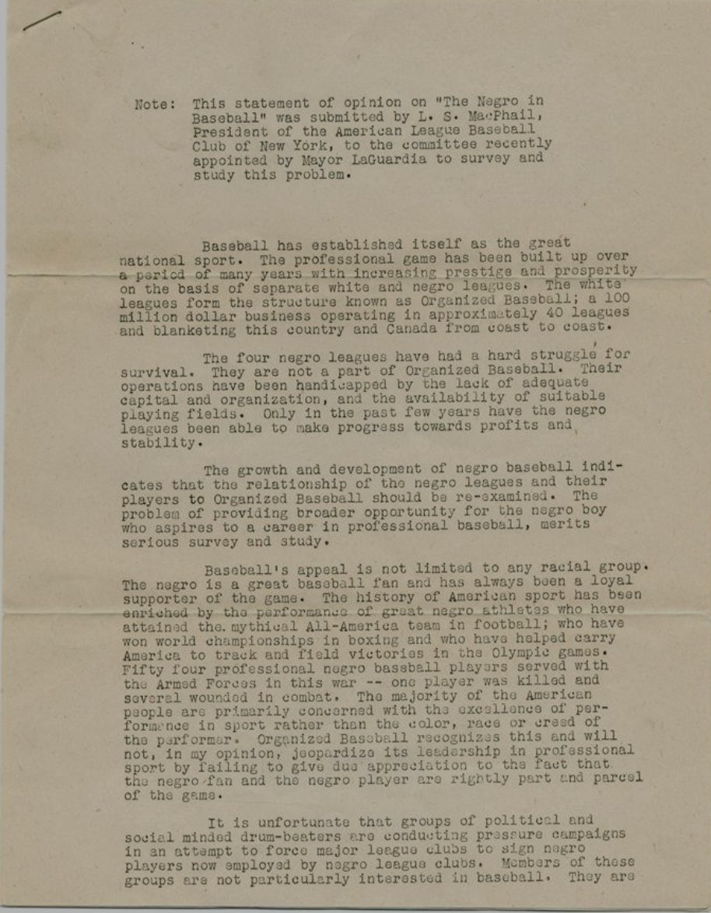

2

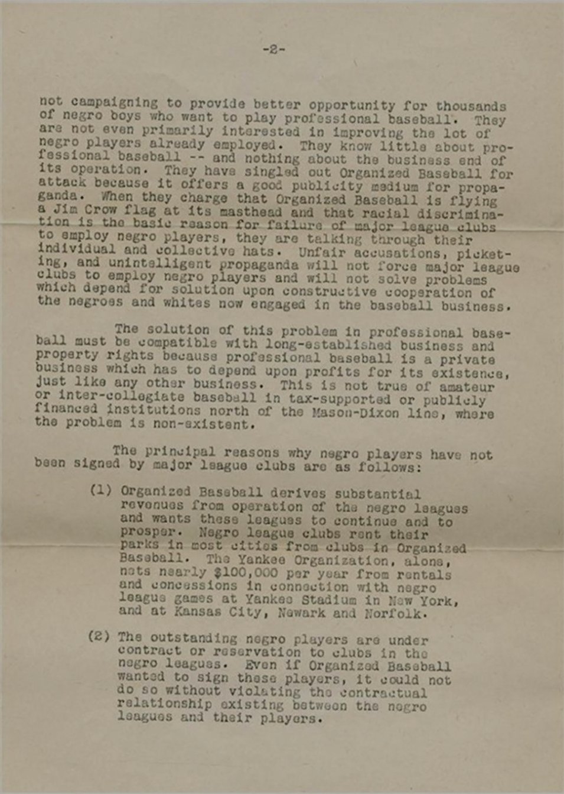

3

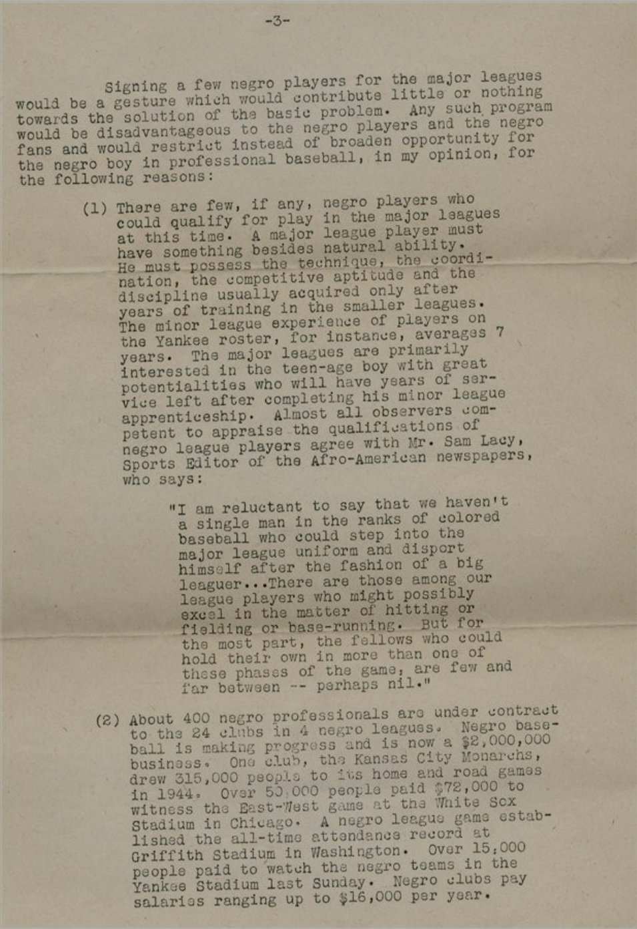

4

